Dify Demo Version (Text-to-SQL Chat Interface):
Admin User Access and Sales Data Retrieval: This section shows the login for the admin user and an example query to find the top 10 customers by sales, along with the generated SQL query and resulting table
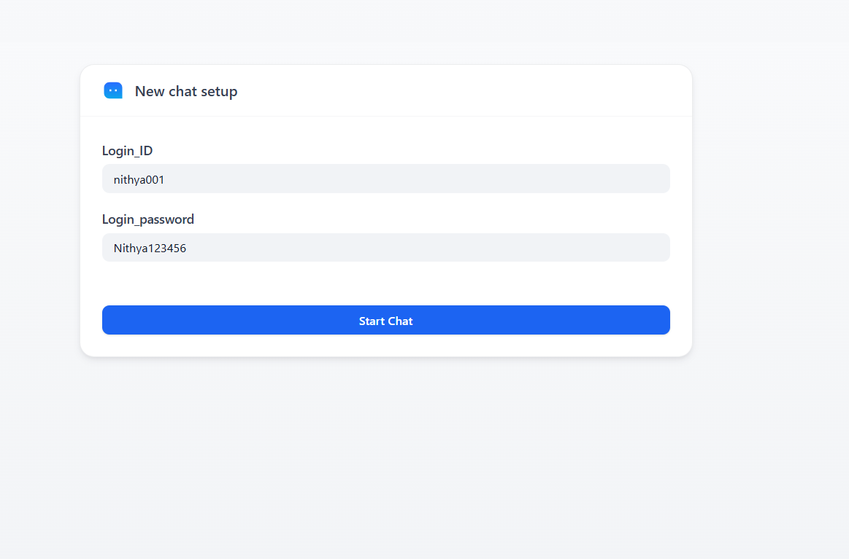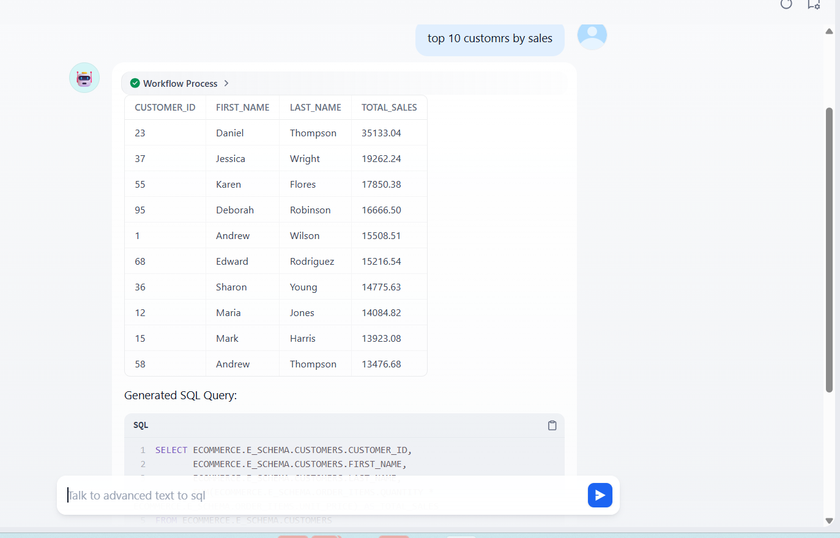

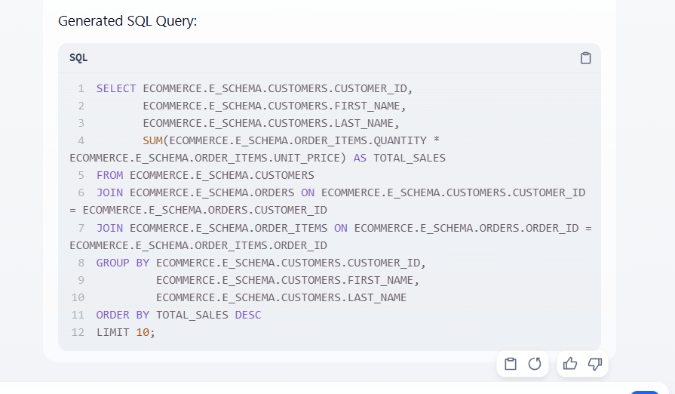

Admin User Restriction on Data Manipulation: This demonstrates the restriction on data manipulation (like trying to delete a customer table) for all departments, resulting in an error message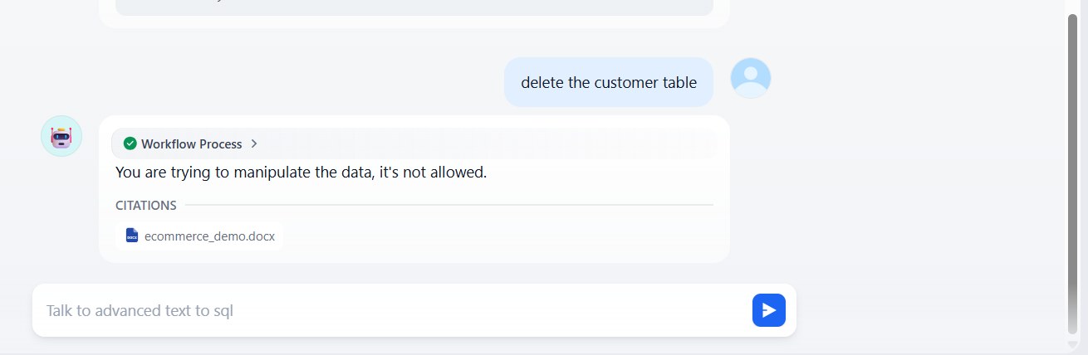

Analyst User Access and Inventory Data Retrieval: This section illustrates the analyst login and a query for "items with low on inventory," showing the resulting data and the generated SQL query.
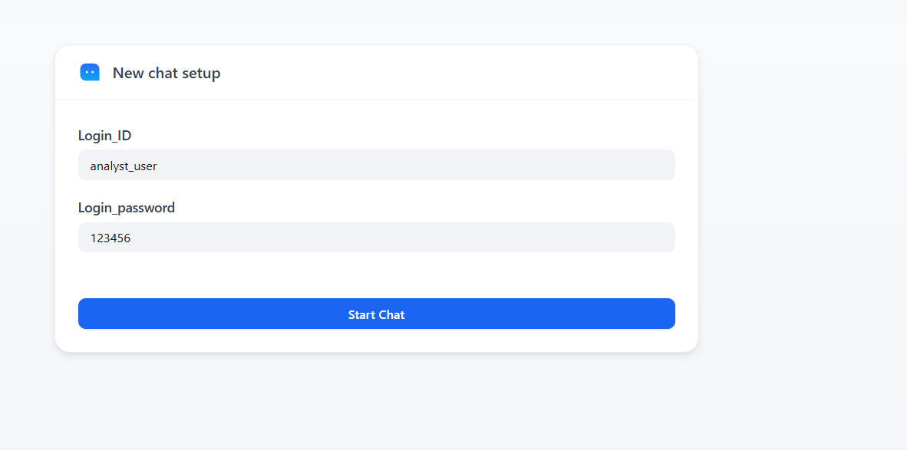
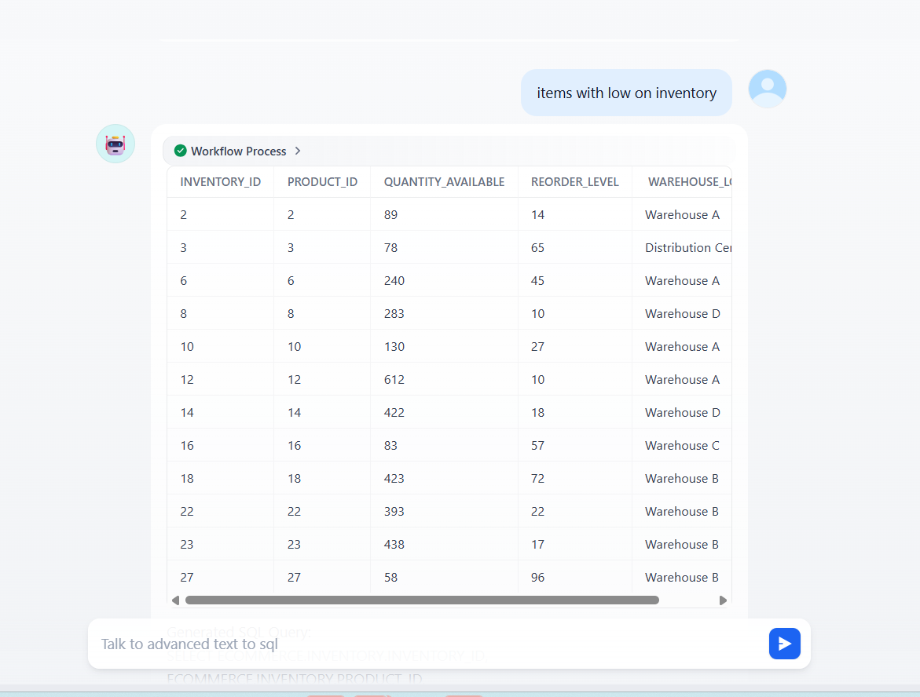
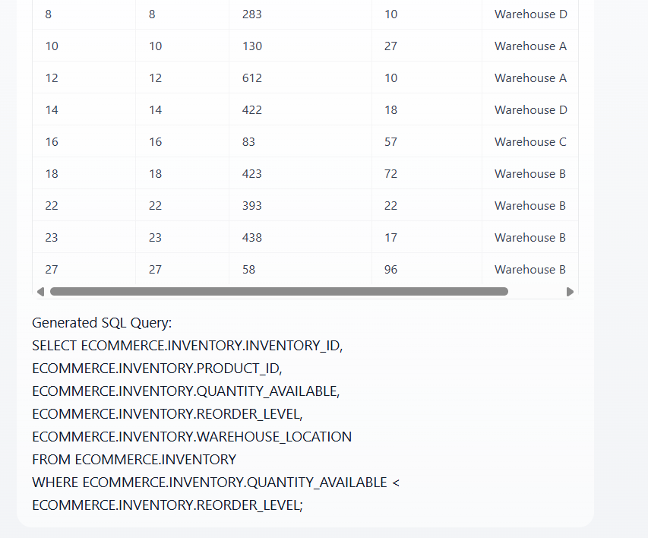
Analyst User Restriction on Finance Data Access: This highlights the access denial when the analyst attempts to query finance-related data (e.g., discounts). 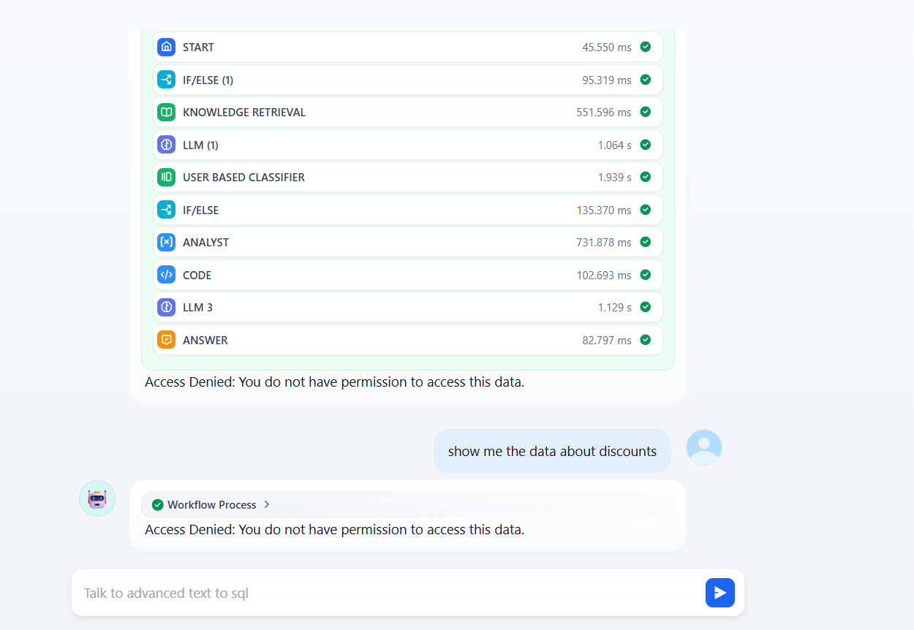
Finance User Access to Finance Data: This shows the finance user's login and successful query for discount table data.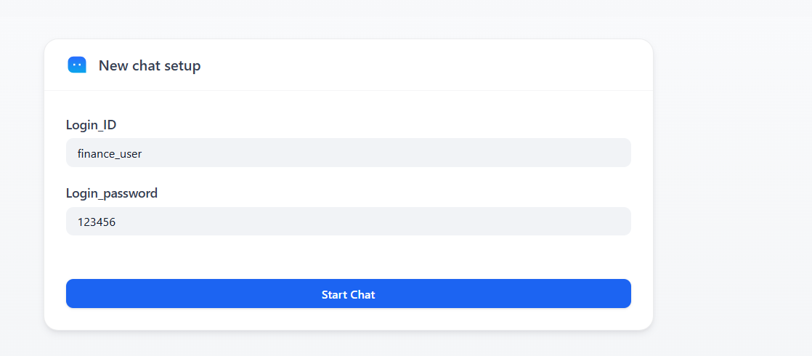
Finance User Restriction on Analyst Data Access: This demonstrates that the finance user is denied permission to access analyst data (e.g., products low on inventory).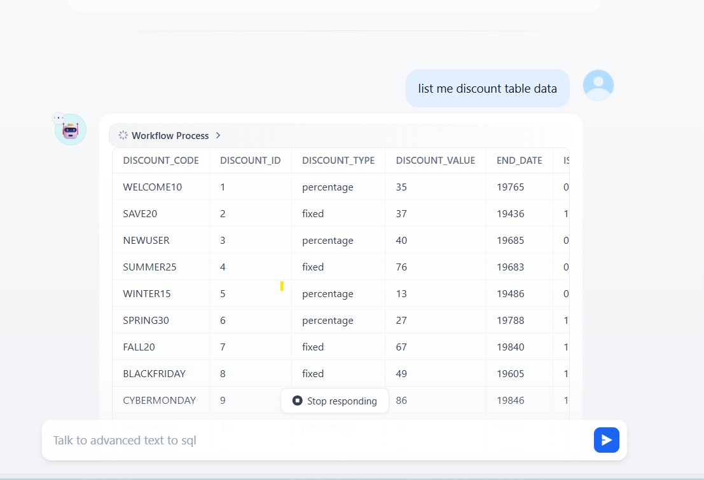
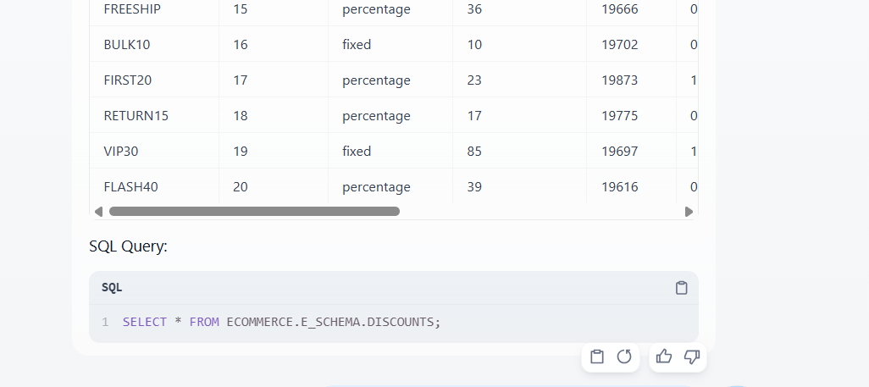

Finance_user cannot accces analyst data
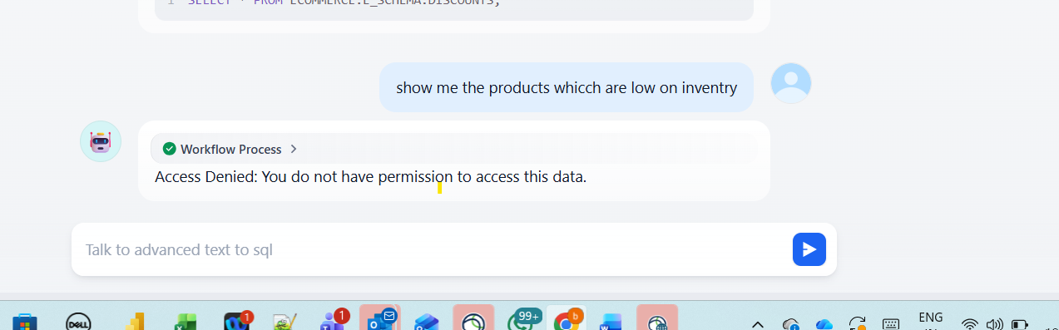

Python Version (Text-to-SQL GenAI Application)
Application Overview and Quick Demo Access: This introduces the "Text-to-SQL GenAI" application and shows the initial screen for quick demo login using pre-configured accounts (like Admin Demo).
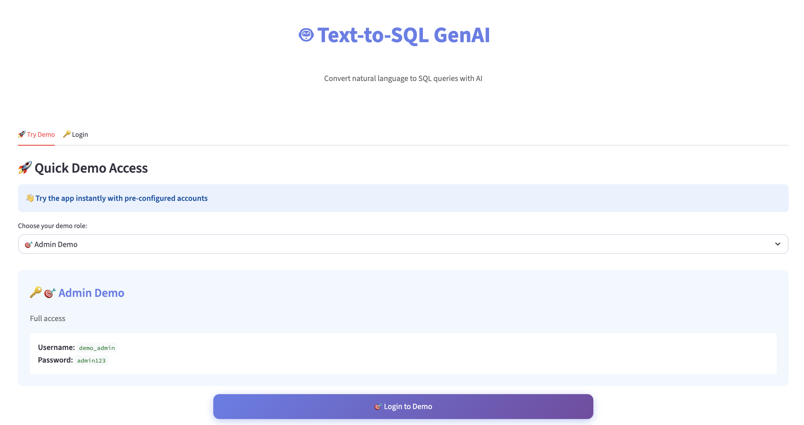
Admin Access Level and AI Configuration: This shows the Admin role interface, including settings for "Show AI reasoning" and "Enable AI Agents".
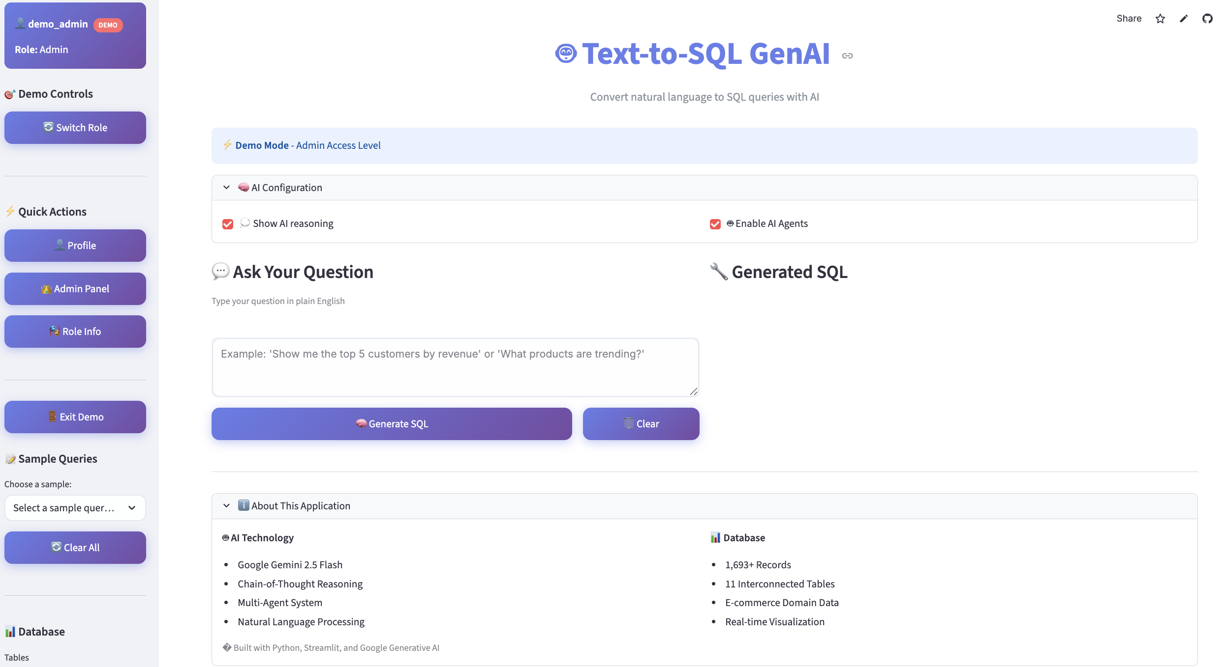
Natural Language Query and AI Reasoning (Example: Popular Product Categories): This demonstrates asking a question in plain English ("What are the most popular product categories?"), detailing the AI's understanding, approach, and confidence score.
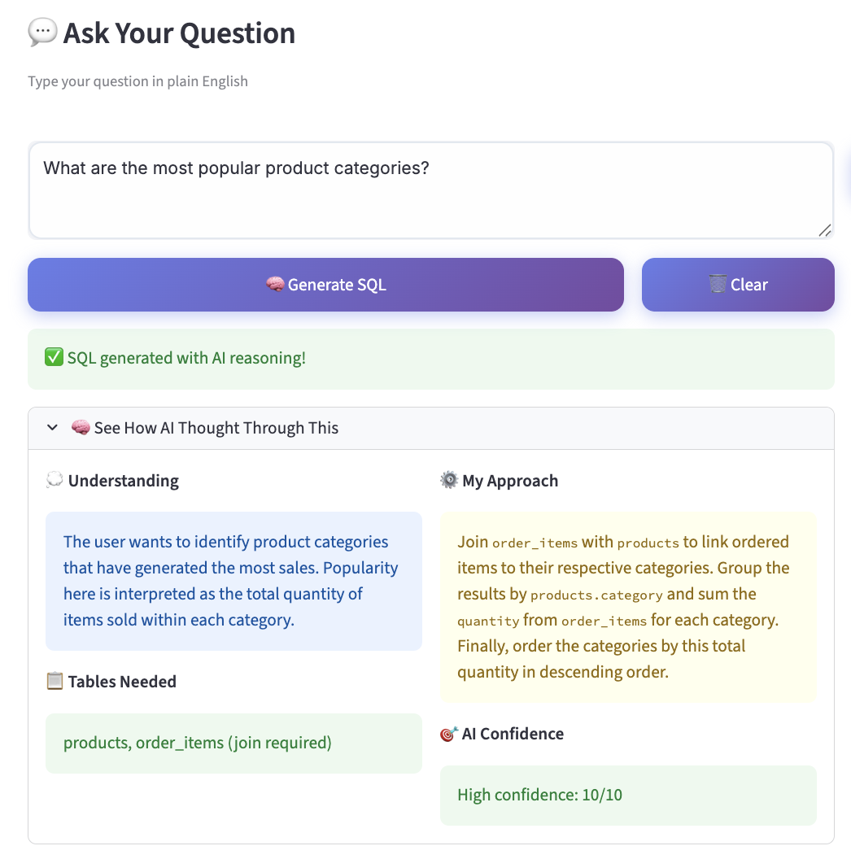
Generated SQL and AI Agents Analysis: This section displays the generated SQL query and the analysis by AI Agents (Planner, Validator, Optimizer) regarding plan, status, and performance tips.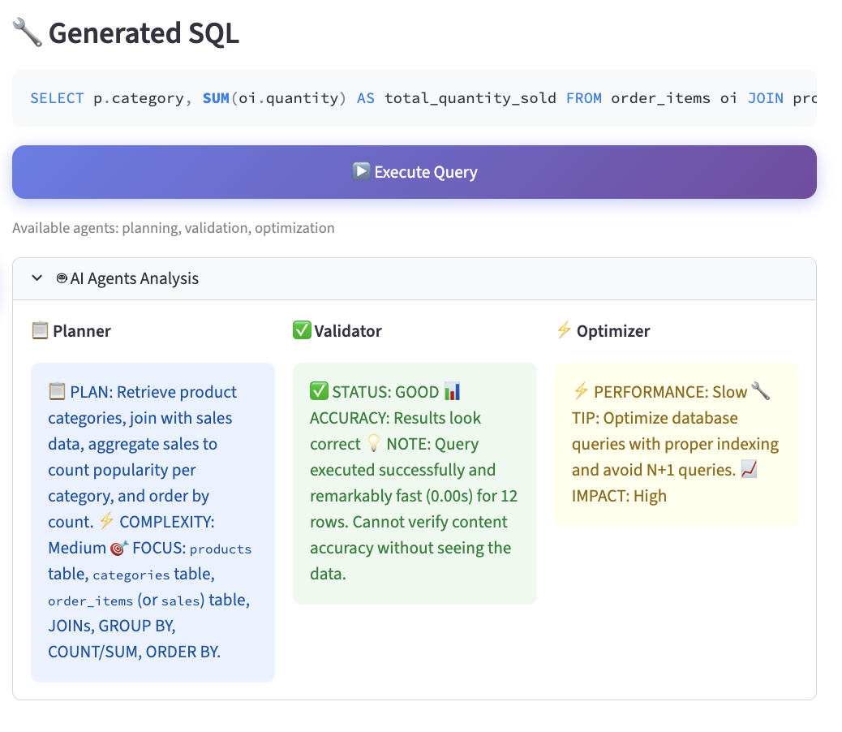

Query Results and Data Visualization: This shows the output of the query execution, including a table of results, a bar chart visualization ("total_quantity_sold by category"), and summary statistics.
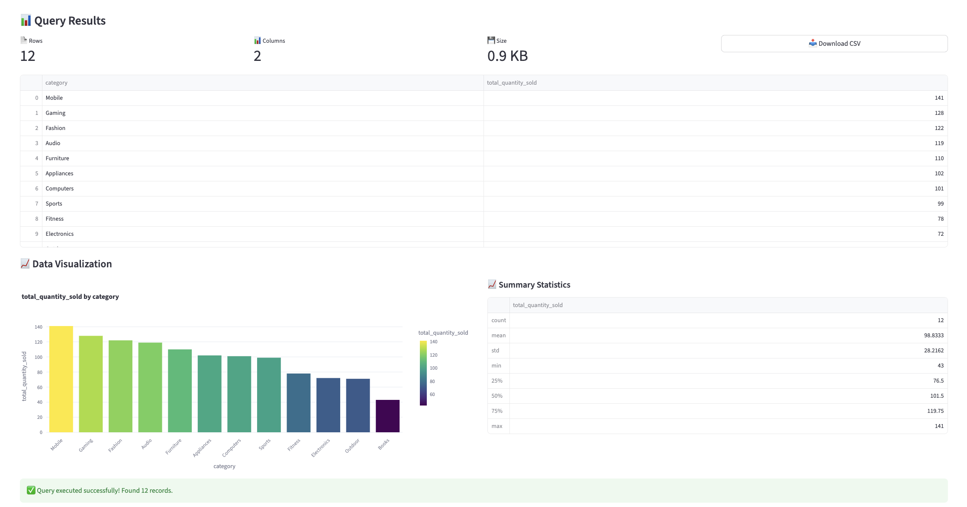

User Profile and Permissions (Admin Role): This view details the extensive permissions granted to the Admin user, such as Read/Write/Delete Data, Manage Users, View Analytics, etc..
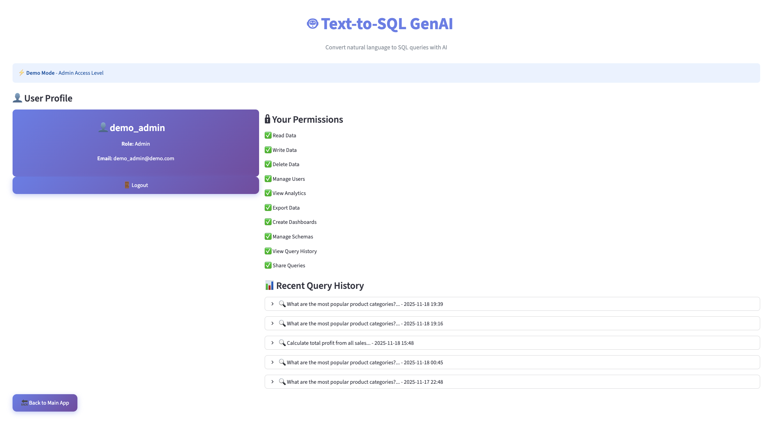

Admin Panel - User Management: This shows the panel for managing users, including the total number of users, active users, admins, and a list of all users and their roles.
